Assessment 03

## **Introduction**

Data presented in this experimental study are both quantitative and qualitative. The cholesterol levels measured are qualitative, continuous and group is qualitative. cholesterol levels measured in each month is dependent. The sample size of this experiment is 16 (9 from each group). The main question that needed to be answered in this study is the relationship between the exercise and diet plan with the level of cholesterol over time.

## **Plots**

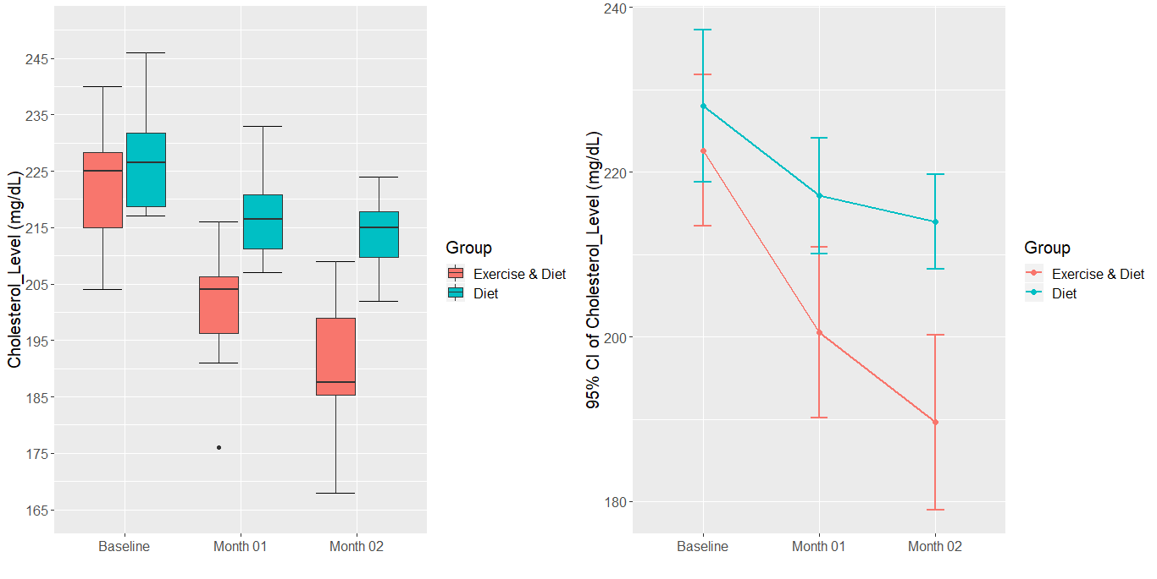

An outlier can be observed in the “Exercise and Diet” group during the month 01 which needed to be investigated.

The mean cholesterol level in both groups is reducing over time.

## **Assumptions**

|  |  |  |  |  |  |  |
| --- | --- | --- | --- | --- | --- | --- |
| Statistics | Group | | | | | |
| Exercise & Diet | | | Diet | | |
| Month | | | Month | | |
| Baseline | 01 | 02 | Baseline | 01 | 02 |
| Sample Size | 8 | 8 | 8 | 8 | 8 | 8 |
| Mean | 222.6 | 200.5 | 189.6 | 228.0 | 217.1 | 214.0 |
| Median | 225.0 | 204.0 | 187.5 | 226.5 | 216.5 | 215.0 |
| Skewness | -0.156 | -0.714 | -0.130 | 0.567 | 0.528 | -0.257 |
| Normally Distributed | Yes | Yes | Yes | Yes | Yes | Yes |
| p-value | 0.8040 | 0.4460 | 0.8479 | 0.1124 | 0.7532 | 0.9506 |
| Equal variances  assumed | Yes (P-Value=0.6942) | | | | | |
| Sphericity  assumed | Yes(P-Value=0.0551) | | | | | |

Null Hypothesis when testing the assumption of normality.

H0 : No difference exists between the sample and hypothetical distribution;

Null Hypothesis when testing the equal variances.

H0: There’s no difference in variances.

Null Hypothesis when testing the Sphericity.

H0: No difference in the variances of the differences.

## **Descriptive statistics**

|  |  |  |  |  |  |  |
| --- | --- | --- | --- | --- | --- | --- |
| Statistics | Group | | | | | |
| Exercise & Diet | | | Diet | | |
| Mont | | | Month | | |
| Baseline | 01 | 02 | Baseline | 01 | 02 |
| Sample Size | 8 | 8 | 8 | 8 | 8 | 8 |
| Mean | 222.6 | 200.5 | 189.6 | 228.0 | 217.1 | 214.0 |
| 95% CI (lower) | 213.43 | 190.15 | 179.01 | 218.76 | 210.10 | 208.24 |
| 95% CI (upper) | 231.82 | 210.85 | 200.24 | 237.24 | 224.15 | 219.76 |
| Standard deviation | 10.99 | 12.38 | 12.69 | 11.06 | 8.41 | 6.89 |
| Min | 204 | 176 | 168 | 217 | 207 | 202 |
| Max | 240 | 216 | 209 | 246 | 233 | 224 |

The mean values suggest that there’s a drop in in weights overtime regardless of the group over time.

## **Statistical inference**

H0: No difference exists in the cholesterol levels over time

H0: No difference exists in the cholesterol levels with respect to subject groups.

H0: No difference exists in cholesterol levels over time with respect to groups.

|  |  |  |  |  |  |  |
| --- | --- | --- | --- | --- | --- | --- |
| |  |  | | --- | --- | | Effects |  | | Measurements | p-value | |  | | --- | | Effect size | |
| Main effects | Group | <0.008 | 0.377 |
| Time | <.001 | 0.496 |
| Simple main effects | Group * Time | <0.001 | 0.134 |

Conclusions:

Since all the p values are < 0.05, All the three null hypothesis can be rejected.

It’s statistically significant *that there’s a different* in the cholesterol levels over time.

It’s statistically significant *that there’s a different* in the cholesterol levels over the subject groups.

It’s statistically significant *that there’s a different* in cholesterol levels over time with respect to groups.

In general, following can be commented on the effect size:

Small if 0.02 <= Effect Size < 0.13

Medium if 0.13 <= Effect Size < 0.26

Large if Effect Size >=0.26

So that the effect size is large with respect to Group and Time, And the effect size medium with respect to Group * Time.

## **Pairwise comparisons**

**Main Effects**

**Time**

|  |  |  |
| --- | --- | --- |
| Months | Difference (mg/dL) | P value |
| Baseline - Month.01 | 16.5 | <.0001 |
| Baseline - Month.02 | 23.5 | <.0001 |
| Month.01 - Month.02 | 7 | 0.0002 |

When we consider the pairwise comparison of time factor only (time in isolation) we can come into a conclusion that all the comparisons that we do are statistically significance.

**Group**

|  |  |  |
| --- | --- | --- |
| Months | Difference (mg/dL) | P value |
| Exercise & Diet - Diet | -15.5 | 0.0080 |

**Simple main effects (interaction effects)**

|  |  |  |  |  |
| --- | --- | --- | --- | --- |
| Months | Exercise & Diet | | Diet | |
| Difference(mg/dL) | P Value | Difference(mg/dL) | P Value |
| Baseline - Month.01 | 22.12 | <.0001 | 10.88 | 0.0001 |
| Baseline - Month.02 | 33 | <.0001 | 14 | <.0001 |
| Month.01 - Month.02 | 10.88 | 0.0001 | 3.12 | 0.3292 |

|  |  |  |
| --- | --- | --- |
| **Month** | **Exercise & Diet - Diet** | **p-value** |
| **Baseline** | -5.38 | 0.3248 |
| Month.01 | -16.62 | 0.0059 |
| Month.02 | -24.38 | 0.0002 |